LINUX COMMANDS – DAY -4

1) less –> provides less data
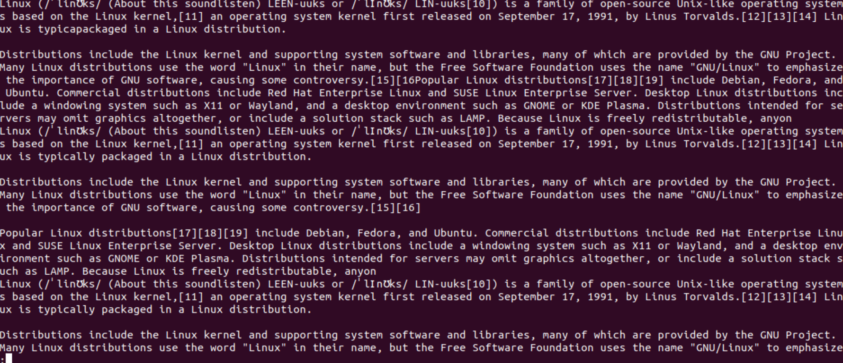
2) less -p –> Finds the particular given word and starts printing from that line and also high that word

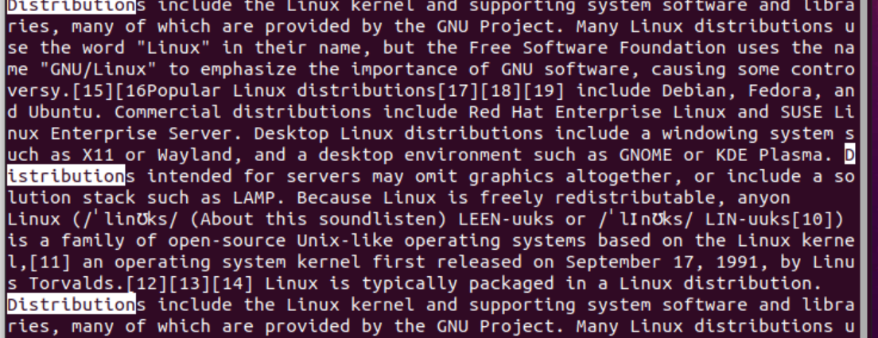
3) less -N –> find the line number of the content.
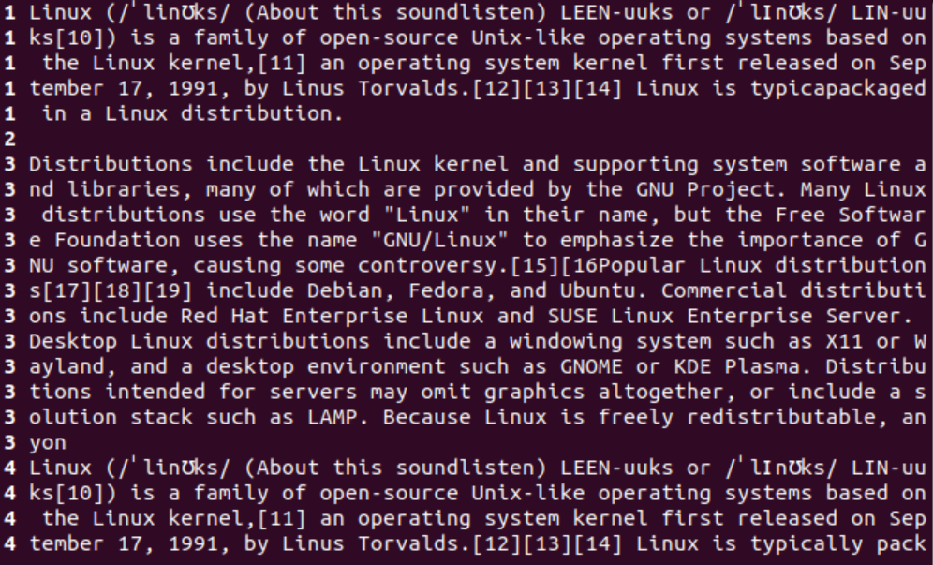
Vim – Text editor
4)which –> Find in which path the given file is present.
5)I,A,a –> used to insert contents into the vim.
6)esc –> for exiting Insert phase.
7):w –> for saving new file.
8):r filename –> to copy one file in another file.
9)dd(keys) –> delete line by line.
10)u –> undo the previous work.
11)x(key) –> delete word by word.
12):q! –>exit without saving.
13):q –>exits from vim editor.
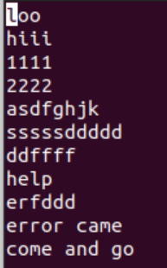
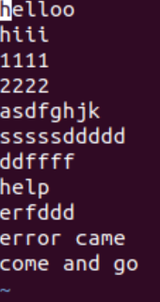

14) tail –> used to display last 10 lines of a file.
15)head –> used to display first 10 lines of a file by default.
16) find –>used to find the location of the file.

